**Multiple Outcomes – Day 1**

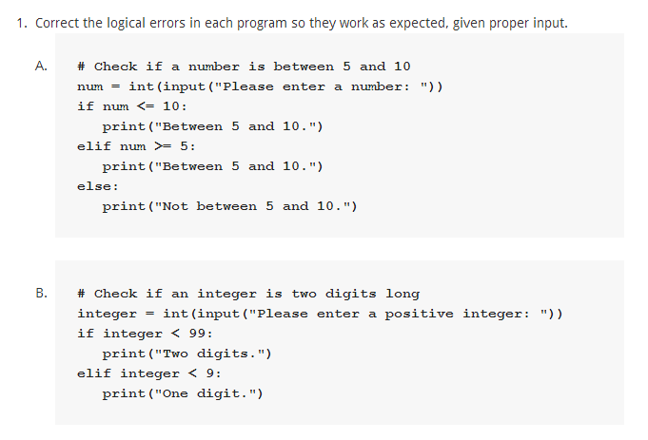

2. Rewrite the following program to use elif.

|  |  |
| --- | --- |
| **wings = int(input**("How many goals did the Wings get? "))  **bad_guys =** int(input("How many did the other team get? "))  **if** wings > bad_guys:  **print(**"The Wings won!!!")  **if** wings < bad_guys:  **print(**"The Stupid Leafs won.")  **if** wings == bad_guys:  **print(**"It was a tie.") |  |

3. Ask the user to enter two numbers, and have your program tell them which number is the **larger** of the two.  Extend this program to also say if they are equal to each other. Use elifs in this program.

4. Ask the user to enter two numbers, and have your program tell them which number is the **smaller** of the two.  Extend this program to also say if they are equal to each other. Use elifs in this program.

5. Determine if an integer entered by the user is positive, negative, or neither. Use elifs.